|  |
| --- |
| International Production Center |
| Performance Test Entry Questionnaire | |

Author: Amit Kulkarni; Jyothi Pujari

Version: 1.1

Date: 8/18/2016

1 Introduction 4

1.1 Purpose 4

1.2 Audience 4

1.3 Overview 4

1.3.1 The first element of the planning document is the project goals. 4

1.3.2 The second element is the project objectives. 5

1.3.3 The third element is a Project Timeline that outlines the sequence, duration, and staff responsibility for tasks in the implementation. 5

2 Project overview 7

2.1 Application description 7

2.2 Projects objectives 7

2.3 BU Information 8

2.3.1 Client Information 8

2.3.2 Contact Information 8

2.4 Expected results delivery 8

3 Application Architecture 9

3.1 Architecture diagram 9

3.2 Platform – Material and Software 10

3.2.1 Servers description 10

3.2.2 Servers components 10

3.3 Database 11

3.4 N&S Layer 11

4 Dataset and user simulation 12

4.1 Dataset 12

4.1.1 Dataset description 12

4.1.2 Dataset creation 12

4.1.3 Dataset reset 12

4.2 User simulation 13

5 Scenarios 14

5.1 Type of users 14

5.2 Functional scenarios 14

5.3 The load tests 14

# Introduction

## Purpose

This document aims at defining the project scope and gathering clients needs and expectations.

It will then help to define measurable tasks that, once completed, will achieve the Goals and will help to define the Project Timeline.

## Audience

The audience of this document is project managers, technical leads, and engineers responsible for a successful benchmark project.

## Overview

The first step for testing is to define goals, objectives, and project timeline.

The output of this process is a **Test Plan Document** that defines these issues going forward.

Each project is planned based on our experience of similar projects. The planning documents are circulated to relevant staff at the appropriate level of detail, for review and agreement.

Planning document schedule the involvement of IPC in advance to allow IPC to meet their ongoing targets. Each person on the project follows the plans with sufficient flexibility to allow appropriate meetings with key individuals.

### The first element of the planning document is the project goals.

The goals broadly define the problems to address and the desired outcome for testing. A typical goal would be:

“the version X is considered to be a high risk implementation based on information from the marketing department or the production department (high transaction rates and data volumes). The goal is to conduct a series of load tests to identify performance/operational bottlenecks and recommend improvement measures.”

### The second element is the project objectives.

The objectives are measurable tasks that, once completed, will achieve the Goals. A typical set of objectives would be:

• Estimate the concurrent user utilization and transactional volumes for the version under Loadtest.

• Simulate that utilization and measure system response time.

• Identify performance/operational bottlenecks and recommend performance improvement measures.

**Identifying Functional scenarios**

To achieve these objectives we would need to identify the functional scenarios with which we can construct the scripts and load test the application.

There should be max 5 functional scenarios. To identify the functional scenarios follow the below example.

Consider an application which has 3 basic modules Employee Time sheet, Leave module and Reports module.

For this application to evaluate the functional scenarios we can focus on the following points.

* What is the volume of navigating the assumed action in production?
* What is the backend area that the navigation targets? Does that include the area in scope for bench?
* Which are the problematic transactions reported by users in production?

With answers to these questions we can identify the following scenarios:

1. Clock in Clock out -🡪Employee time sheet module (most navigated scenario)
2. Report or request absence 🡪Leave module
3. Generate report for new joiners and leavers 🡪Reports module

In this way we can cover most of the area in application and achieve the desired objectives.

### The third element is a Project Timeline that outlines the sequence, duration, and staff responsibility for tasks in the implementation.

While the Project Timeline varies among engagements, the sequence of events typically resembles:

• **Preparation:** this includes tasks like planning and environment setup.

• **Development:** is to create the scenario and test scripts that will be run to load the system.

• **Execution/Analysis:** is to run the scenario. The data gathered during the run is used to analyze system performance, develop suggestions for system improvement, and implement those improvements. The scenario may be iteratively re-run to achieve load test goals.

• **Results Summary:** the purpose here is to report the outcome of the work performed for the load test.

# Project overview

## Application description

|  |  |
| --- | --- |
| **Questions** | **Answers** |
| Name of the application: | Workday Enhanced Integration |
| Version to be tested: | 1.0 |
| Is it the first load test of the application? | YES |
| Is the application already deployed in production? | NO |
| How many customers are using the application? | TBD |
| How many users are using the application? | TBD |

**Please provide a short description of the application:**

This is an enhancement of Workday Standard Integration. This application captures local payroll data of the Clients via Workday system using REST API Services.

## Projects objectives

**What are the objectives of this load test project?**

(Example: to validate application architecture, to determine application capacity…)

* Determine Application capacity
* Determine the responsiveness and stability
* User Experience under load

**What are the key criteria to be met?**

(Example: response time, number of concurrent users…)

* Average throughput in requests per second
* Peak throughput (What is the most traffic that you get over a certain period?)
* Throughput distribution by API endpoint (Do you have any endpoint that gets substantially more traffic than any others?)
* Throughput distribution by users (A few generate most traffic, or is it more evenly distributed?)

## BU Information

### Client Information

|  |  |  |  |
| --- | --- | --- | --- |
| BU | BU Department | Business Executive | Sponsor |
| Abhishek Ranjan | GVPD | Michelle Hernandez | Abhishek Ranjan |

### Contact Information

|  |  |  |
| --- | --- | --- |
| **Name** | **Email 🖅 Telephone 🖁** | **Role** |
| Amit Bhavsar | Amit.bhavsar@adp.com | Application Development Manager |
| Amit Kulkarni | Amit.kulkarni@adp.com | Quality Assurance Manager |
| Jyothi Pujari | Jyothi.pujari@adp.com | Architect |
| Mike Arts | Mike_Arts@adp.com | Technical Lead |
|  |  |  |

## Expected results delivery

|  |  |
| --- | --- |
| When do you expect the first results to be delivered? | TBD |
| When do you expect the project to be completed? | TBD |

# Application Architecture

## Architecture diagram

**Please provide a diagram of the application architecture** (for example as deployed in production)

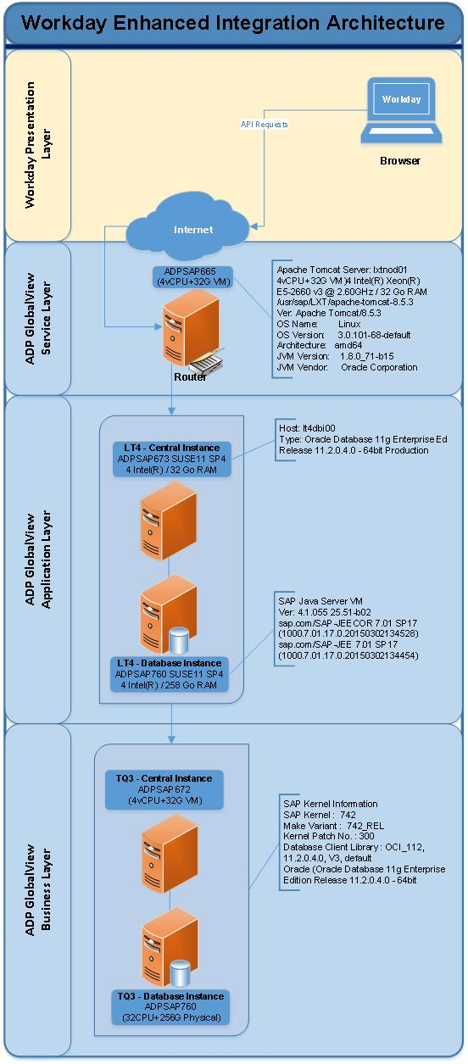

## Platform – Material and Software

### Servers description

Please describe the servers you need to setup the application in benchmark environment:

(or just the name of the production server if you want the same configuration)

|  |  |  |  |  |
| --- | --- | --- | --- | --- |
| **Name** | **Model** | **OS** | **CPU** | **RAM** |
| Router | VM | Linux SUSE11 SP4 | 4vCPU | 32G |
| Application Server | VM | Linux SUSE11 SP4 | 4 Intel(R) | 32G |
| SAP Server | VM | Linux SUSE11 SP4 | 4vCPU | 32G |

### Servers components

Please describe the middleware and software (including the version) that need to be deployed on the different servers

|  |  |  |
| --- | --- | --- |
| **Service** | **Server** | **Middleware / Software** |
| Service Layer | Router | Tomcat 8.5.3 |
| Application Layer | Application Server | JAVA 2 SDK 1.4.2_18  Oracle Database 11g Enterprise Edition Release 11.2.0.4.0 - 64bit |
| Business Layer | Business Server | Oracle Database 11g Enterprise Edition Release 11.2.0.4.0 - 64bit |

## Database

**Name and version of the database to be used:**

**If Oracle is to be used,**

ADPSAP760 SUSE11 SP4, 4 Intel(R) / 258 Go RAM

## N&S Layer

**Should a network and security layer be built?**

Please provide service id in staging or production

Not Applicable for initial scope.

# Dataset and user simulation

## Dataset

### Dataset description

**Please provide a description of the dataset:**

Example: the dataset is made of 200 employees (user001 to user200), 10 administrators (admin001 to admin100) and 50 experts(users201 to user250)

5 – HR Admin users

5- PY Admin users

200 - General Users

### Dataset creation

**If the dataset is to be copied from an existing database**, please provide us the name of the instance and schema to be copied in benchmark environment:

**If the dataset is to be created by scripts**, please provide us the scripts along with the questionnaire.

**Note:** data should be anonymized before being used in benchmark environment.

### Dataset reset

In order to be able to compare results of two iterations of a given test, dataset should be reset after each test if it is modified by the test. The preferred method to reset the dataset is a SQL script. Some other methods can be considered.

**How do you plan to reset the dataset?**

Clone the employees after each iteration.

## User simulation

**Should we simulate a specific web browser?** **If yes, please precise name and version**.

**Should we simulate user cache or should we clear the cache between each user iteration?**

Kindly clear the cache.

# Scenarios

## Type of users

**What are the different types of users to be simulated?**

Example: employee, administrator, expert…

Administrator, Employee, Supervisor, Manager

## Functional scenarios

Please provide a short description of the functional scenarios to be played:

Refer to the link for details

|  |  |  |
| --- | --- | --- |
| **#** | **Description** | **User type** |
| Example | Submit leave request | Employee |
| Sc 1 |  |  |
| Sc 2 |  |  |
| Sc 3 |  |  |
| Sc 4 |  |  |

A full scenario description should be provided in a separate document.

## The load tests

This sections aims at describing the load tests to be played. It can be a single functional scenario or a combination of functional scenarios.

|  |  |  |  |
| --- | --- | --- | --- |
| **#** | **# users** | **Scenario repartition** | **Objective** |
| Example | 500 | 60% scenario 1 and 40% scenario 2 | Determine application capacity or  determine impact of sc2 on sc1 |
| LT 1 |  |  |  |
| LT 2 |  |  |  |
| LT 3 |  |  |  |
| LT 4 |  |  |  |